READING PART 1
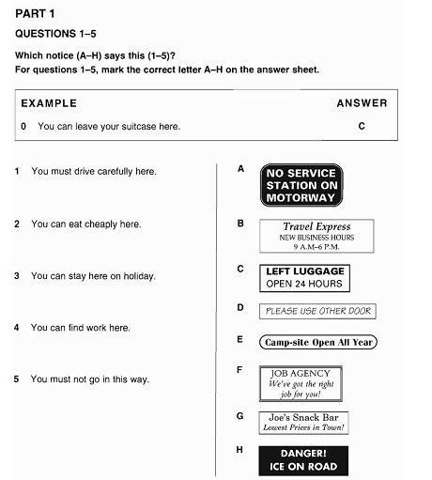

LISTENING PART 1
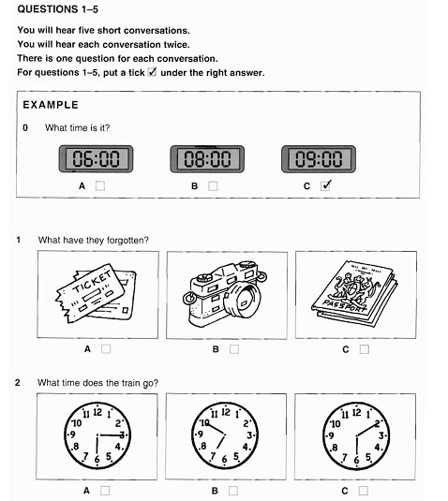

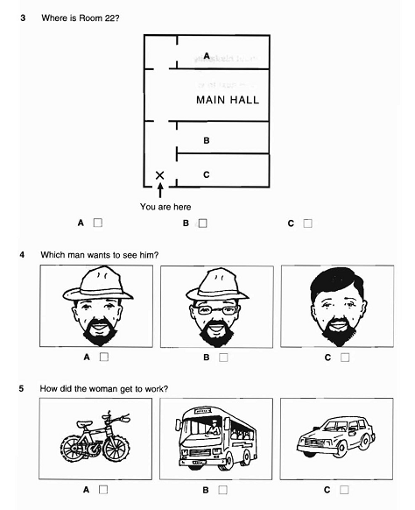

READING KEYS

LISTENING KEYS
SOURCE:
Cambridge ESOL. 2004. Cambridge English KET 1. Cambridge University Press.

